STEPS FOR MyChart ACTIVATION

1) Download the MyChart app on your smartphone device through the App Store (Apple Phones) or the Google Play store (Android phones).


**Key Step**Once inside the MyChart app, you will want to select our organization (PPOC in yellow letters)

2) Access your email and locate the email sent by:
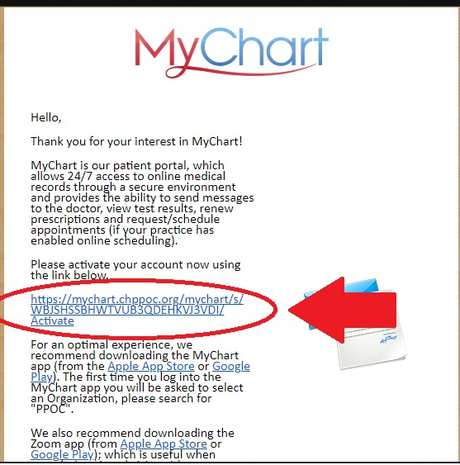
Greater Lowell Pediatrics. If you did not receive and email invite then please call our office.
<donotreply@chppoc.org>

3) Sign up using the hyperlink that is included in the email (the hyperlink contains your unique Activation Code which is used when you access the sign-up process via the hyperlink). Keep in mind when it asks for Date of Birth, it will be your PERSONAL date of birth, NOT your child’s.

By default, your username is first and last name all one word in CAPS (ex. Frank Furt will be FRANKFURT) Also keep in mind that it is your name and not your child.

4) Access MyChart via the mobile app, or at: https://mychart.chppoc.org/MyChart/Authentication/Login?

